Module 1a

Software Layout

# Starting Lego Mindstorms

## Desktop Icon

The icon if available on your desktop is shown below.

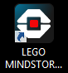

## Start Menu

The icon can be found under “Lego Mindstorm EV3”

# Opening Screen

The opening screen will depend on your version of the software.

## Home Edition

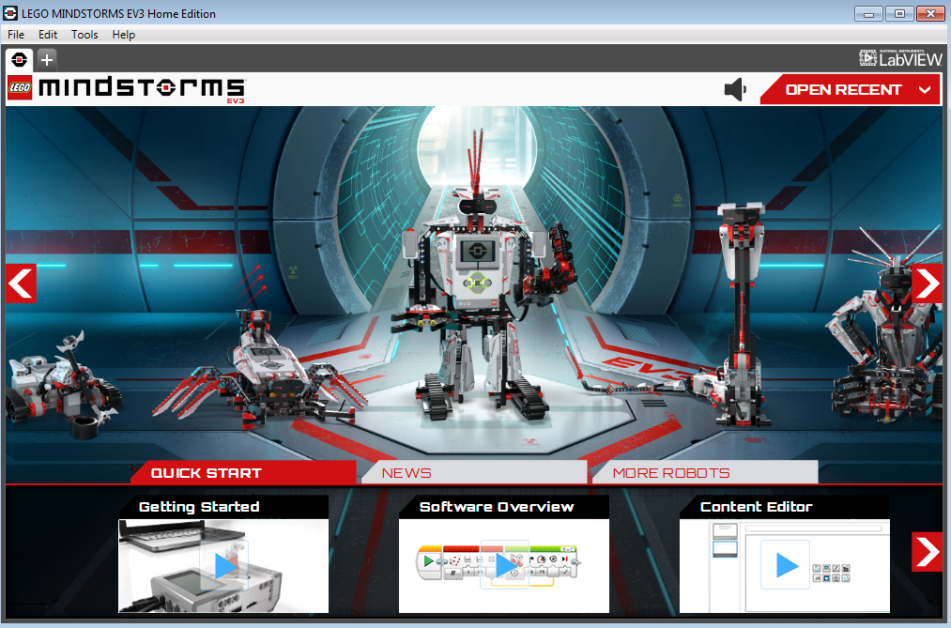

## Education Edition

# Projects

## Starting a Project



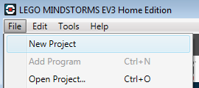

## Project Screen

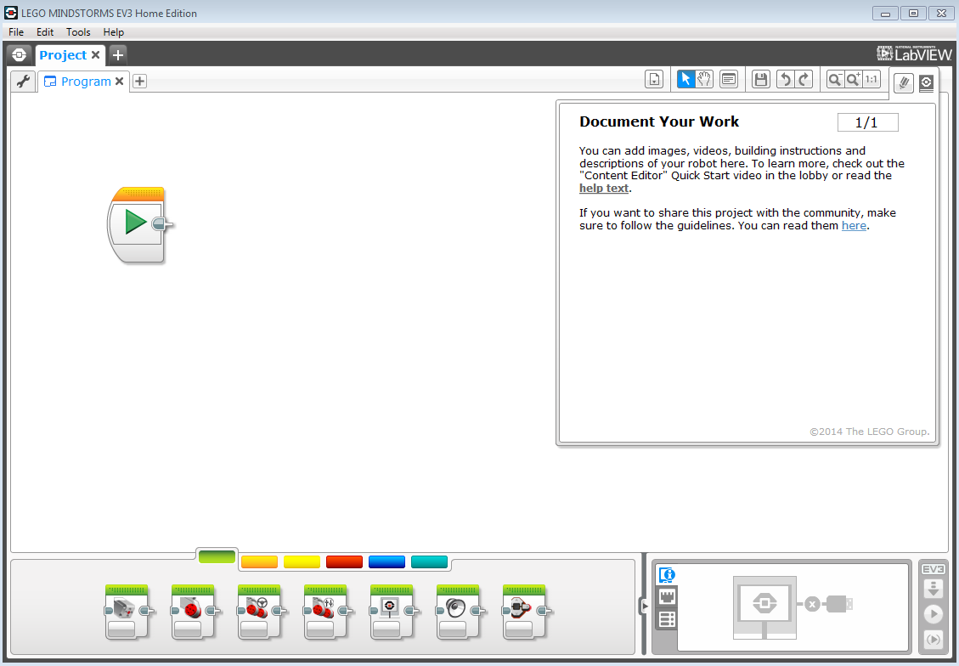

Project Name

Program Name

Click here to minimize

“Document Your Work”

# Saving a Project

## Name your Program

1. Double click the name of your program to rename it.

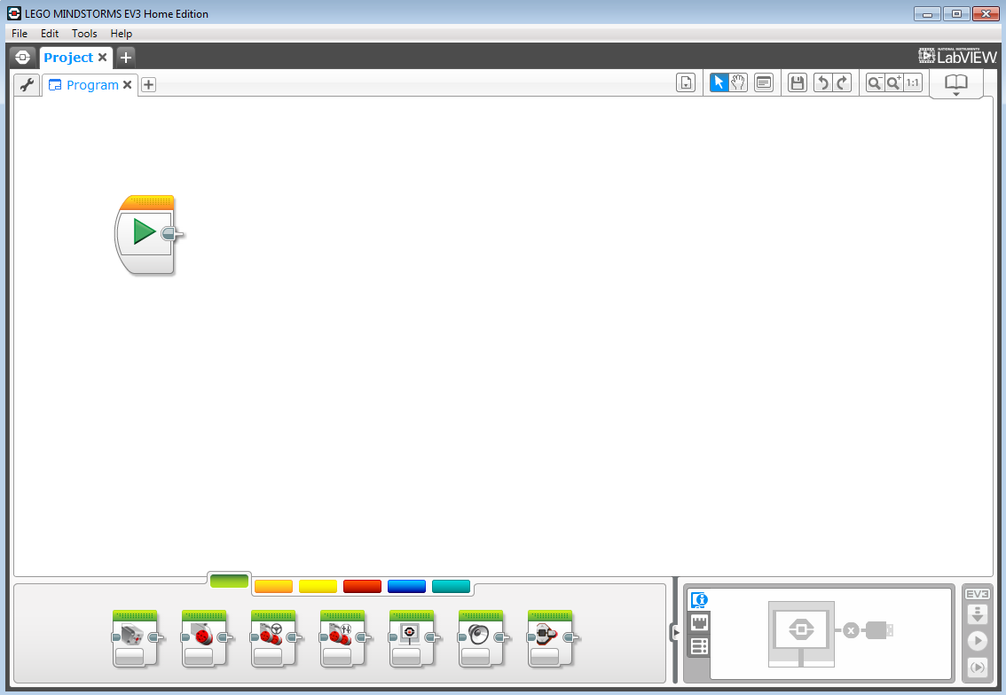

1. Make sure the whole word is highlighted

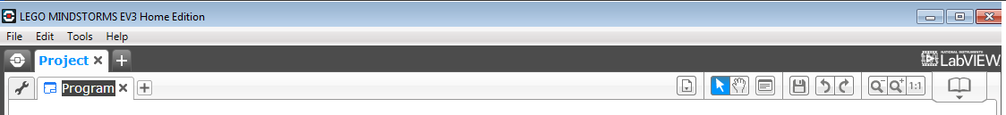

1. Type the new name and press Enter or click somewhere else on the screen.

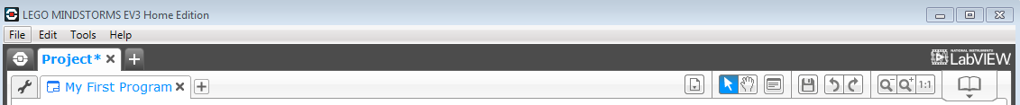

## Save your Project

You can save your project one of the two ways indicated below.

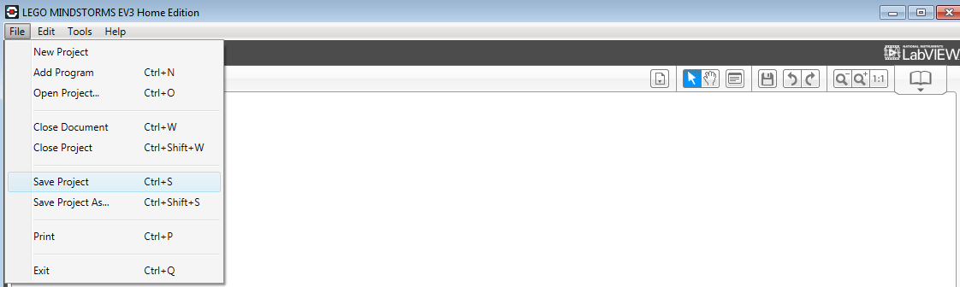

## Adding Blocks

Your program will be made up of blocks located at the bottom of the screen. There are 2 ways to place blocks.

* CLICK-HOLD, DRAG, RELEASE
* CLICK, DRAG, CLICK

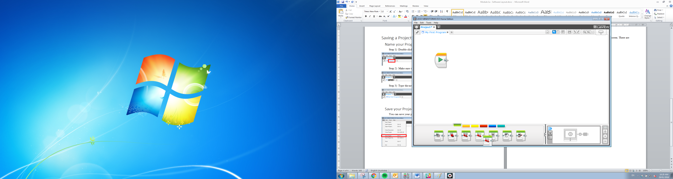

CLICK

When dragging the block close to another block, a grey square will tell you where the block will connect.

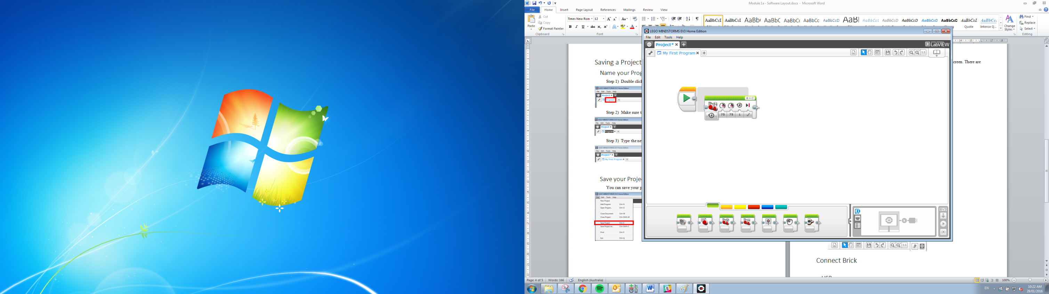

DRAG

After release the block will connect where the grey square was.

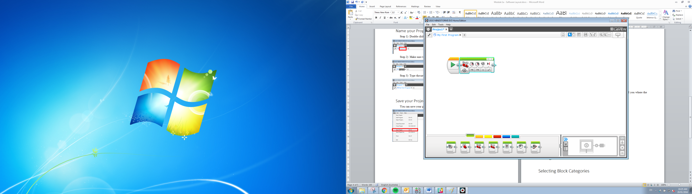

RELEASE

## Moving Blocks

Once a block is placed and you want to move it. You have to select the dotted section on the block and use the CLICK-HOLD, DRAG, RELEASE technique. Here are some examples of dotted sections on different blocks.

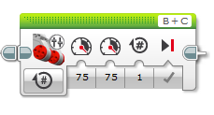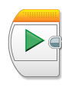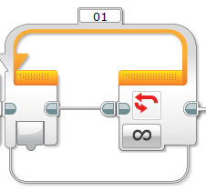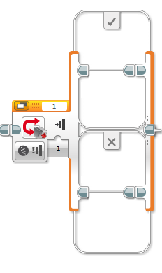

## Removing Blocks

You can remove b

# Wiring Blocks

# Selecting Block Categories

# Tools



# Connect Brick

## USB

## Bluetooth

# Download and Play Project